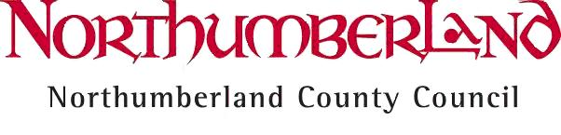

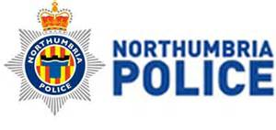
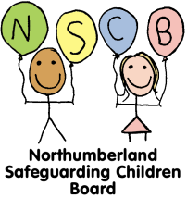

Operation Encompass - Northumberland

Information for schools to add to website

What is Operation Encompass?
The purpose of Operation Encompass is to safeguard and support children and young people who have been involved in a domestic abuse incident. Following an incident at home, children will often arrive at school distressed, upset and unprepared for the day.
Northumberland County Council, the police and nominated Key Adults in school will be working together to make sure that school staff are made aware of an incident early enough to support pupils in school.

Why is Operation Encompass being introduced in Northumberland?
Operation Encompass was initially launched in Plymouth in February 2011 to address a shortcoming in the early sharing of information with schools. Since then several pilots have been set up across the UK, including Gateshead, South Tyneside and North Tyneside, and has proved to be very successful in providing appropriate support in a timely manner. Pilots across the UK have reported positive outcomes for many children and young people.
Northumberland County Council, Northumbria Police and all schools in will be taking part in the scheme, to help provide additional new support which will benefit children and young people in Northumberland and improve multi-agency sharing of information.

How will it work?
Schools across Northumberland will nominate two members of staff who will be known as Key Adults. All Key Adults will attend specific training to the role in preparation for Operation Encompass.
Each morning a police officer will review all domestic abuse incidents that occur outside of school but which might have had an impact on a child or young person attending school the following day. Where children were present, witnessed or involved in a domestic abuse incident and aged between 4 and 16 years old, the officer will send this information to Children’s Social Care.
Staff from Children’s Social Care will send this information in a secure format to the identified Key Adult. The Key Adult will check their emails every day and the staff in contact with those pupils will then be in an informed position to support them in a way that is right for the child.
This information will be shared on school days during school term and, when incidents occur on a Friday, Saturday, Sunday or over a holiday period, the police will contact Children’s Social Care the following Monday.
All parents or carers will be sent a letter from their child's school informing them about Operation Encompass.

When will Operation Encompass be launched in Northumberland?
Operation Encompass will launch in January 2017.
For more information about Operation Encompass, please contact your school or visit:
http://www.operationencompass.org/
http://www.bbc.co.uk/programmes/p03y9r5h

