Y4 Virtual Cricket Competition
Welcome to the Y4 Virtual Cricket Challenge, we hope ALL Y4s can get involved with this at school ( Intra School Games), this is a class challenge, so we would like you all to get involved with your class. When everyone has completed the challenge, work out your class’s average for each of the skills and send the results to your SGO by Friday 11th December ( Inter School Games). The school with the greatest average score will represent their area at the County School Games Final in June 2021.
Please use a tennis ball and a plastic kwik cricket bat for this activity.
Before you attempt this challenge for your final scores, make sure you have had plenty of practice, to enable your skill to be the best it can be.
- Fielding/catching skills- With a tennis ball face a wall suitable for throwing against. Stand 2m back from the wall and throw the ball at the wall, catch with good catching hands. Have a practice and then with an adult/sports leader timing you, count how many catches you can make in 1 minute? 1 point per catch
- Fielding /throwing skills - Using an overarm throw can you throw past a 10 m mark, 20m mark or 30m mark . Place a starting mark which you can run upto but not over. You can have 5 attempts and score on each one. 1pt/2pt/3pt per marker crossed.
- Bowling skills - You've got ten attempts with your ball to try and hit the stumps from an underarm bowl, the ball may bounce upto 2 times before it hits the stumps. Stand no closer than 14 meters away from the stumps. 1 point for each stumping.
- Batting Skills- Holding your bat in two hands, in 1 minute how many ‘Keepie Uppies’ can you do? 1 point per ‘ keepie uppie’
- Running Skills- Run between two line markers that are 14 metres apart, ground your bat over the line at each line before turning to run back. How many runs can you score in 1 Minute . 1 run scores 1 point
Can you match the School Games Value to the correct sentence? Can you apply these values to your challenge?
My score will be a true representation of what I achieve. I can work with a partner to coach and/ or count their score. I know I can do this.
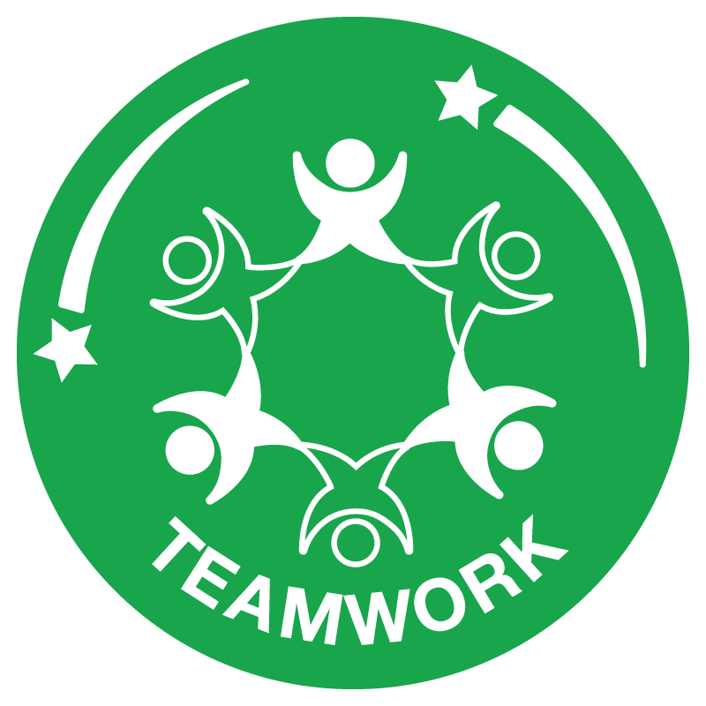
I am enthusiastic about what I am going to do. My coaching comments will be positive and I will celebrate everyone's score. I will not give up.

